9.37. (a) The outline is given below. There are 40 subjects, so we assign 10 subjects to each of the four treatments. The four treatments are outlined:

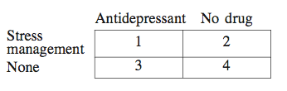

(b) Assign labels 01 through 40 (in alphabetical order). The full randomization is easy with the Simple Random Sample applet: each successive sample leaves the population hopper, so that you need only click Sample three times to assign 30 subjects to three groups; the 10 subjects remaining in the hopper are the fourth group. Alternatively, line 125 of Table B gives the following subjects for Group 1: 21 Jiang, 37 Suarez, 18 Hersch, 23 Kim, 19 Hurwitz, 03 Alawi, 39 Wilson 24 Landers, 27 Morgan, and 13 Garrett.

